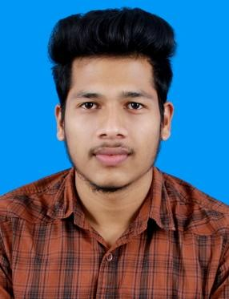

ADITHYAN K V

Email : [adithyankv21@gmail.com](mailto:adithyankv21@gmail.com)

Mob : 8129352759, 8111884759

CAREER OBJECTIVE

To continuously pursue my skills, knowledge and experience by getting involved in challenging environment and stabilize them for personal and organizational growth to the best of my ability.

ACADEMIC PROFILE

DEGREE GRADUATON UNIVERSITY OF CALICUT

2016 – 2019 Bachelor of Computer Application (BCA)

AWH College of Science and Technology, Anakkara

PROFESSIONAL DIPLOMA CONTINUING EDUCATION KERALA

2014 - 2015 Diploma in Hardware and Networking

Govt. Polytechnic College, Shoranur

HIGHER SECONDARY KERALA STATE EDUCATION BOARD

2012 - 2014 +2 Science, GHSS Peringode

HIGH SCHOOL KERALA STATE EDUCATION BOARD

2012 SSLC

COMPUTER SKILLS

* Platforms: Windows and Linux.
* Programming Languages: C\C++, C#, Java, DBMS, Php, Python
* Software Packages: Microsoft Packages and Adobe Photoshop.

TECHNICAL SKILLS

* Planning & Implementing System Administration & Network Setup
* Managing Enterprise Network & Wide Area Network
* Implementation of Enterprise Network & Wide Area Network
* Microsoft Technologies: DNS & DHCP
* Operating System: Windows

PROFESSIONAL EXPERIENCES

Responsibilities:

* Assembling PC and Its Maintenance.
* Installing different OS like Windows (Win 7,8 ,10) and Linux.
* Antivirus Updating
* Troubleshooting on Laptop Hardware
* Connecting and Sharing Network devices in a LAN

Responsibilities:

* Microsoft & Hardware
* Assembling PC and Its Maintenance.
* Installing Different OS in Laptops and Desktops.
* Taking backup of client Machines.
* Installing & Updating Antivirus.
* Installing & Maintaining Most types of Printers.
* Troubleshooting through online Software.
* Normal and APC ups installation & Its Maintenance.
* Installation and Maintenance of Microsoft Software Packages.
* Troubleshooting on Motherboard and HDDs.
* Implementation and Replacement of Hardware spares on PCs & Lap.
* Cabling

Knowledge of connectors and UTP cables and its structures crimping & punching.

LINGUSTICS

* ENGLISH: Read, Write & Speak
* MALAYALAM: Read, Write & Speak
* HINDI: Read, Write & Speak
* TAMIL: Speak and Understand.

PERSONAL DETAILS

Name: ADITHYAN K V

DOB: 25/05/1997

Gender: MALE

Father’s name: VIJAYAN K K

Mother’s name: MALATHI

Nationality: INDIAN

Marital status: SINGLE

DECLARATION

I hereby declare that the above informations is true to the best of my knowledge and belief.

Date:

Place: ADITHYAN K V